Darley Princess 5678 1234

HOME | WHAT WE DO | GALLERY | ABOUT US
ABOUT US
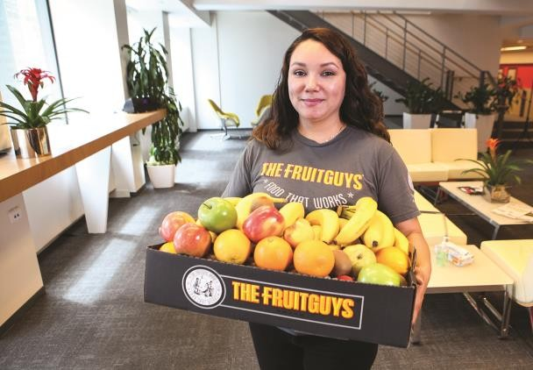 | CHECK OUT OUR PRODUCTS & SERVICES  Each week our buyers choose what's most delicious in season near you and create special regional fruit and veggie mixes. Purchase our classic mixes or bulk produce. Our healthy snacks can be purchased in variety mixes, with or without fruit, and in bulk.Click here to check out our products!
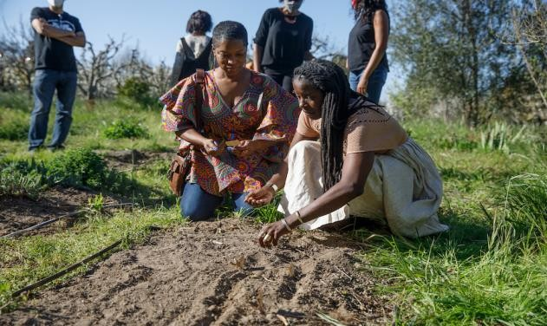 | We donate a minimum value of 20% of annual profits to fight hunger and support sustainable farming practices through grants to small farms.

Darley Princess 5678 1234

 | SATISFACTION GUARANTEED  We guarantee our products 100% and will replace your order or issue a credit if you are ever unhappy with the quality. No hassle
 | DECIDE HOW MUCH TO ORDER  We recommend starting with a box with 2 pieces of fruit per person per week. For a 25- person office: try a Harvest Mix, Large (50-servings), delivered weekly; and a Thoughtful Snacks Mix, Medium (75-servings), delivered every other week. Connect with us and we can help you craft a custom program
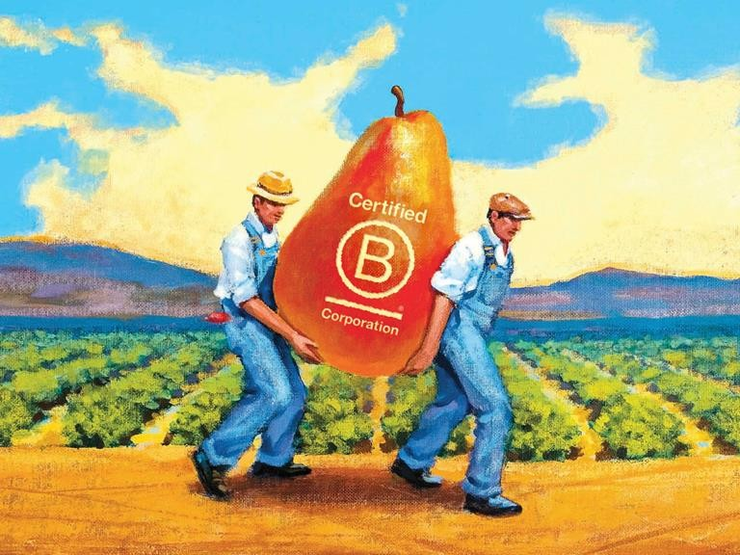 | Our Mission  Since 1998, The FruitGuys has been on a mission to sustainable agriculture and combat hunger. Buying your fruit from The FruitGuys helps our family-owned and operated B Corp business sustain the small independent farmers we support and source from and the hunger-relief non-profits we donate to through our GoodWorks programs. We support this mission by donating a minimum value of 20% annual profits to fight hunger and support sustainable farming practices.

